SYSTEM ANALYSIS DOCUMENTATION (SAD)
UMHackathon 2026
umhackathon@um.edu.my
Group | newbee
Group member | - WONG JIA HUI  - TAN CAI JUAN  - LEE JUN RUI
Domain | 2

- Introduction:

This System Analysis Documentation covers the technical architecture, data flow design, component interactions, and design decisions behind GigOptimizer AI, an intelligent decision-support system for gig economy workers in Malaysia.

  - Purpose:

This document serves as the authoritative technical reference for the GigOptimizer AI system. It covers the role of Z.AI GLM as the central intelligence layer, how prompts are constructed and responses parsed, how structured and unstructured data flow through the system, and how each backend component interacts with the frontend dashboard.

Key areas covered: system architecture, LLM integration as a service layer, GLM dependency diagram, sequence diagrams for core flows, technology stack, data flow diagrams, functional requirements, non-functional requirements, monitoring strategy, and team contributions.

  - Background:

GigOptimizer AI was developed in response to a validated market gap: 1.1 million Malaysian gig workers lack intelligent decision tools, resulting in suboptimal task selection, missed surge windows, and income volatility averaging ±MYR 120 per week. The system architecture was designed to be lightweight (single Python file backend, single HTML file frontend) for hackathon deployment speed while demonstrating production-grade reasoning through GLM integration.

  - Target Stakeholder
Stakeholder | Role | System Expectation
Gig Workers (Riders, Drivers, Freelancers) | Primary end users receive GLM-generated recommendations through the dashboard | Clear, actionable task recommendations explained in plain language with quantified income impact
Gig Platform Operators | Future integration partners — provide live task feeds via API | Reliable API contract, modular backend that can consume live task data without architectural changes
Development Team | Build and maintain the Flask backend and frontend dashboard | Clean separation between GLM logic and business logic, reproducible demo fallback for offline testing
QA Team | Validate GLM output quality, API reliability, and recommendation accuracy | Defined prompt/response schemas, quantified pass criteria, scenario-based test cases
Z.AI / Hackathon Judges | Evaluate GLM integration depth and real-world impact | Demonstrable GLM dependency — system degrades meaningfully without GLM

- System Architecture & Design

  - High Level Architecture

    - Overview:
Dimension | Detail
System Type | Web Application — Client/Server with AI Service Layer
Architecture Pattern | Monolithic Flask Backend with GLM as External Service Layer
Frontend | Single-Page Application (SPA) — HTML5 / Vanilla JS / CSS3
Backend | Python 3.11 / Flask 3.0 / Flask-CORS — Single app.py module
AI Core | Z.AI GLM ilmu-glm-5.1 accessed via HTTPS REST API (api.ilmu.ai/v1/chat/completions)
Deployment | Local development — Flask dev server (port 5000); production-ready for any Python WSGI host
Data Storage | In-memory (no database) — worker profiles and task data are seeded at server start
GigOptimizer AI follows a three-tier architecture: the frontend dashboard communicates exclusively with the Flask backend via REST API. The Flask backend acts as a business logic and orchestration layer. The Z.AI GLM service is called by the backend — it is never called directly from the frontend, ensuring API key security and centralised prompt management.
    - LLM as Service Layer (GLM Integration Architecture)
GLM is not a peripheral feature in GigOptimizer AI. It is the core reasoning engine. Every decision-support output (task ranking, schedule generation, income strategy, trade-off analysis) is generated through a GLM inference call. If the GLM layer is removed, the system can only display raw numerical metrics, meaning that it cannot generate insights, recommendations, strategies, or decisions.

    - Dependency Diagram
The following describes the GLM integration flow for each of the four analysis endpoints:

Step 1: Context Block Construction (Backend)
• Worker profile data is retrieved from the in-memory WORKER_PROFILES dictionary (vehicle type, rating, earnings history, preferred task types, fuel cost per km, peak hours).
• Task data is retrieved from the SAMPLE_TASKS list and enriched with pre-computed metrics via the compute_task_metrics() function (fuel cost, gross pay, net pay, hourly rate, efficiency score).
• These two blocks — structured numerical data and profile context — are serialised as a formatted string and injected into the GLM user prompt.

Step 2: Prompt Assembly (call_glm function)
• A role-specific system prompt defines GLM's expert persona and mandates the exact JSON output schema (field names, types, constraints).
• The user prompt contains the full context block (worker + tasks + environmental signals).
• The combined payload is sent to https://api.ilmu.ai/v1/chat/completions with model: ilmu-glm-5.1, temperature 0.4–0.7 (endpoint-specific), and a 30-second timeout.

Step 3: Response Parsing & Downstream Routing
• On HTTP 200: GLM response text is extracted from data['choices'][0]['message']['content'].
• Markdown fences (```json, ```) are stripped if present — a common GLM response formatting artefact.
• The cleaned string is parsed with json.loads(). On parse failure, the raw text is returned with a parse_error flag.
• On HTTP error or timeout: the demo fallback generator is invoked, producing deterministic scenario-accurate output.
• The final response is returned to the frontend as JSON with a glm_powered boolean flag indicating whether the output originated from a live GLM call.

Token Budget & Context Window Management
• Worker profile block: ~200 tokens (fixed per worker)
• Task data block (8 tasks + metrics): ~800 tokens
• System prompt + JSON schema instruction: ~300 tokens
• Total per call: ~1,300–2,000 tokens — well within GLM-5.1 context limits
• Pre-filtering: If task count exceeds 20, backend sorts by raw efficiency score and injects only the top 10 to prevent context overflow

API Endpoint | Caller | GLM Role |  | Response Target
GET /api/tasks | Frontend Dashboard | None — pure computation |  | Task list with pre-computed metrics
POST /api/analyze/tasks | Frontend (Run GLM Analysis button) |  | Rank tasks, explain reasoning, identify risks, project income |  | Top 3 recommendations + income projection + avoidance alerts
POST /api/analyze/schedule | Frontend (Generate Schedule button) | Reason about surge windows, clustering, energy patterns |  | Hour-by-hour schedule + projected earnings + time saved
POST /api/analyze/income | Frontend (Analyze Income button) | Interpret earnings history, generate strategies, forecast |  | Revenue strategies + trend analysis + monthly forecast
POST /api/analyze/tradeoff | Frontend (Analyze Trade-off button) | Score tasks across 4 dimensions, identify hidden factors |  | Winner + comparison matrix + decision explanation
Table 1 API Component Interaction Map

    - Sequence Diagram (Task Analysis Flow)
The following describes the end-to-end interaction sequence for the core GLM Task Analysis flow:
Step | Actor | Action | System Response
1 | Worker | Opens Task Selection panel, selects worker profile from dropdown | Frontend sends GET /api/tasks?worker_id=W001 to Flask
2 | Flask Backend | Retrieves WORKER_PROFILES[W001] and enriches SAMPLE_TASKS with compute_task_metrics() | Returns JSON array of 8 tasks with computed metrics to frontend
3 | Frontend | Renders task cards with gross pay, net pay, and hourly rate | Worker sees all available tasks
4 | Worker | Clicks 'Run GLM Analysis' | Frontend sends POST /api/analyze/tasks with worker_id body
5 | Flask Backend | Constructs context block: worker profile + enriched task metrics | Builds system prompt (JSON schema) + user prompt (context)
6 | Flask Backend | Calls call_glm() → POST to api.ilmu.ai/v1/chat/completions | Waits for GLM response (timeout: 30s)
7 | Z.AI GLM | Reasons across all task metrics, worker profile, and environmental signals | Returns JSON: top 3 recommendations, income projection, key insight, avoid list
8 | Flask Backend | Strips Markdown fences, parses JSON, sets glm_powered: true | Returns structured analysis to frontend
9 | Frontend | Renders recommendation cards with rank, reason, risk badge, and net MYR | Worker sees ranked tasks with explanations
10 | Worker | Reads recommendation and accepts or rejects the suggested task | Decision made — system remains advisory
Table 2 Sequence Diagram

  - Technological Stack
Layer | Technology | Justification
Frontend | HTML5 / Vanilla JS / CSS3 (Single File) | Zero build-tool overhead for hackathon deployment. CSS variables and vanilla fetch() provide full dashboard functionality without React/Vue dependencies.
Backend Framework | Python 3.11 / Flask 3.0 | Lightweight WSGI framework. Minimal boilerplate for REST API construction. Flask-CORS handles cross-origin requests from the frontend without infrastructure changes.
AI Core | Z.AI GLM ilmu-glm-5.1 via HTTPS REST | Central reasoning engine. Selected for structured + unstructured data fusion, reliable JSON output mode, and context-aware multi-step reasoning. See PRD Section 4.3.1 for full justification.
HTTP Client | Python requests library | Simple synchronous HTTPS client with timeout support. Sufficient for GLM API calls in the current monolithic architecture.
Environment Management | python-dotenv | Secure API key injection from .env file. Prevents key exposure in source code.
CORS Handling | flask-cors | Enables frontend (file://) to call Flask API (localhost:5000) without browser CORS errors.
Data Layer | In-Memory Python Dictionaries | WORKER_PROFILES and SAMPLE_TASKS are seeded at server start. Eliminates database dependency for hackathon scope while preserving production upgrade path to PostgreSQL/Redis.
Font & Design | Google Fonts (Syne + Space Mono) / CSS Custom Properties | Distinctive industrial-terminal aesthetic that differentiates from generic AI dashboards. Loaded from CDN — no local assets required.

  - Key Data Flows
2.3.1 Data Flow: Task Analysis (Structured + Unstructured Fusion)
External Entities: Gig Worker (human), Z.AI GLM API (external service)
Internal Processes: Task Enrichment Engine, GLM Prompt Builder, GLM Response Parser, Recommendation Renderer
Data Stores: WORKER_PROFILES (in-memory), SAMPLE_TASKS (in-memory)
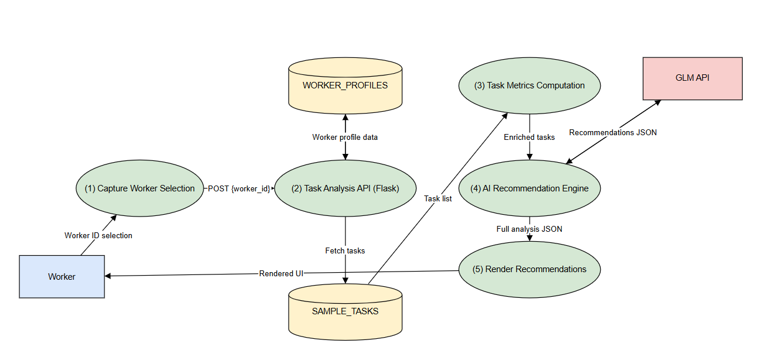
Figure 1 Data Flow Diagram
2.3.2 Normalised Data Schema
GigOptimizer AI uses in-memory data structures equivalent to the following normalised logical schema:

Worker Profile (WORKER_PROFILES)
Field | Type | Description
worker_id (PK) | String | Unique worker identifier (e.g., W001)
name | String | Worker display name
rating | Float | Platform rating (0.0–5.0)
vehicle | Enum | motorcycle | car | bicycle
weekly_earnings | Array[Float] | 7-day rolling earnings history (MYR)
completed_tasks | Integer | Total lifetime tasks completed
preferred_types | Array[String] | Task type preferences (e.g., delivery, ride_hail)
peak_hours | Enum | morning | evening | flexible
fuel_cost_per_km | Float | Vehicle-specific fuel cost (MYR/km)

Task (SAMPLE_TASKS)
Field | Type | Description
id (PK) | String | Unique task identifier (e.g., T001)
title | String | Human-readable task description (unstructured)
type | Enum | delivery | food_delivery | ride_hail | freelance_design | freelance_data
distance_km | Float | Task distance (0 for remote tasks)
estimated_minutes | Integer | Estimated task duration
payout_myr | Float | Base payout before surge
surge_multiplier | Float | Surge pricing multiplier (1.0 = no surge)
rating_requirement | Float | Minimum worker rating required
time_window | String | Availability window (unstructured — e.g., '17:30-19:00' or 'flexible')
weather | Enum | clear | rain | n/a — environmental signal for GLM context
traffic | Enum | low | medium | high | n/a — environmental signal for GLM context

Computed Task Metrics (compute_task_metrics — derived, not stored)
Derived Field | Formula | Purpose
fuel_cost | distance_km × fuel_cost_per_km | Actual cost deduction based on worker's vehicle
gross_pay | payout_myr × surge_multiplier | Pre-fuel earnings
net_pay | gross_pay − fuel_cost | True take-home after cost
hourly_rate | (net_pay / estimated_minutes) × 60 | Normalised productivity metric for GLM comparison
efficiency_score | (net_pay / estimated_minutes) × 10 | Dimensionless ranking score for pre-filtering

2.3.3 EDA-Driven Schema Validation
The data schema defined in Section 4.2 was validated against a real Malaysian gig worker dataset through exploratory data analysis before development began. This section documents how each EDA finding maps to a specific schema field or design decision.

EDA Finding | Schema Impact | Design Decision
Current offer vs. suggested price scatter shows systematic deviation from 1:1 line | Justifies retaining both payout_myr (raw offer) and computed net_pay (derived) as separate fields | GLM receives both values — it reasons about the gap, not just the number
Fuel cost variance widens beyond 4 km (heteroscedastic) | Validates per-vehicle fuel_cost_per_km in Worker schema rather than a global constant | Motorcycle: MYR 0.18/km, Car: MYR 0.35/km, Bicycle: MYR 0.00/km
Data Entry and Food Delivery have highest median hourly income | Validates preferred_types as a meaningful GLM context variable | Workers with matching preferred types receive higher-weighted recommendations
Peak period produces higher upper-quartile outliers, not higher medians | Validates best_work_period as a risk signal, not a guaranteed multiplier | GLM is instructed to flag surge recommendations with explicit risk caveats
Outliers present in all task type distributions (hourly income up to MYR 560) | Validates efficiency_score pre-filter — extreme outliers are legitimate, not noise | Pre-filter retains top 10 by efficiency, so genuine high-value tasks are never dropped

- Functional Requirements & Scope
  - Minimum Viable Product — Core Features
# | Feature | Description | GLM Dependency
1 | GLM Task Ranking | Worker selects profile; system returns top 3 tasks ranked by GLM with reasons, risk flags, net MYR, and income projection vs random selection. | Critical — without GLM, only unsorted raw metrics are available
2 | Smart Schedule Generation | Worker sets earnings target; GLM generates hour-by-hour schedule with surge window awareness, geographic task clustering, and break recommendations. | Critical — GLM generates the schedule; rule-based fallback cannot reason about clustering or surge windows
3 | Income Strategy Analysis | GLM interprets 7-day earnings history and returns trend analysis, 3 revenue strategies with MYR uplift estimates, monthly forecast, and stability score. | Critical — GLM interprets unstructured earnings patterns; without it, system shows only a static average
4 | Trade-off Decision Analysis | Worker selects 2 tasks; GLM scores both across 4 dimensions and returns a winner, comparison matrix, hidden factors, and conditions for preferring the other option. | Critical — multi-dimensional reasoning is exclusively GLM-generated
5 | Multi-Profile Worker Dashboard | Frontend supports 3 worker profiles (motorcycle, car, bicycle) with all GLM outputs dynamically adjusted to the selected worker's constraints. | Moderate — worker context is the key GLM input variable

  - Non-Functional Requirements (NFRs)
Quality | Requirement | Implementation
GLM Response Latency | GLM calls must return within 3 seconds under normal load | 30-second timeout configured in requests.post(); demo fallback activates on timeout
Availability | System must remain functional without live GLM API access | Demo fallback mode produces realistic scenario-accurate outputs when API is unavailable; glm_powered: false flag is set
Cost Efficiency | Average token cost per session must not exceed USD 0.01 | Task pre-filtering caps context at top 10 tasks; temperature tuning reduces exploratory token usage; fixed system prompt length ~300 tokens
Maintainability | GLM prompt logic must be separable from business logic | call_glm() is a single isolated function; all 4 analysis endpoints construct prompts independently and call call_glm() — no circular dependencies
Reliability | JSON parsing failures must not crash the API | try/except wraps all JSON parse operations; raw_text fallback preserves GLM output even if JSON schema deviates; demo fallback provides full structural output on API failure
Security | API key must not be exposed in frontend or version control | API_KEY loaded from .env via python-dotenv; .env.example provided with placeholder; key never transmitted to or from frontend
Scalability | Backend must support concurrent requests without blocking | Flask dev server handles lightweight concurrency; production upgrade path to Gunicorn/uWSGI requires no code changes

  - Out of Scope / Future Enhancements
- Live Grab/Lalamove/Fiverr API integration for real task feeds
- PostgreSQL or Redis persistence for worker earnings history
- Mobile application (React Native) for field use by workers on smartphones
- Multi-language support — Bahasa Malaysia dashboard
- Automated task acceptance and platform write-back (beyond advisory mode)
- Real-time GPS-based geographic task clustering using Google Maps API
- Fleet management dashboard for gig platform operators

- Monitor, Evaluation, Assumptions & Dependencies
  - Technical Evaluation:
    - Grayscale Rollout & A/B Testing:
Phase 1 (Hackathon): System deployed in demo mode to all evaluators. GLM-powered outputs and demo fallback outputs are both tagged with glm_powered flag for transparent evaluation.

Phase 2 (Production): New GLM prompt revisions are released to 10% of active users initially, with earnings improvement metrics tracked. Prompt variants A (current) and B (revised) are compared on recommendation acceptance rate and self-reported earnings uplift over 7 days. Rollout progresses to 50% → 100% if recommendation acceptance rate improves by ≥5%.

    - Emergency Rollback (ER) & Golden Release:
If GLM API error rate exceeds 15% over a 5-minute window, the system automatically routes all analysis requests to the demo fallback generators (the Golden State). This ensures zero downtime for workers even during GLM API outages. The rollback is automatic (Python exception handling) — no manual intervention required.

    - Priority Matrix:
Priority | Trigger Condition | Action
P1 — Critical | GLM API returns HTTP 5xx for >30% of calls over 2 minutes | Auto-activate demo fallback; alert development team; log all failed prompts for replay testing
P2 — High | GLM JSON parse failure rate exceeds 10% (schema deviation) | Review system prompt schema constraints; tighten JSON output instruction; test with temperature reduction
P3 — Medium | Average GLM response latency exceeds 4 seconds | Reduce context block size; enable prompt caching; consider pre-computing top-5 task subset before GLM injection
P4 — Low | Worker reports recommendation does not match expected task type | Audit worker profile preference alignment; add preference weight multiplier to context block

  - Monitoring:
• Backend console logs all GLM API calls with: endpoint, worker_id, response status, response time, glm_powered flag, and token estimate.
• Frontend displays a subtle indicator (GLM-5.1 tag / Demo Mode label) on all analysis outputs so workers and evaluators know the source of each insight.
• In production, structured logging (JSON format) would feed into a monitoring dashboard (e.g., Grafana) tracking: GLM call success rate, average latency, fallback activation frequency, and per-worker recommendation acceptance rate.
  - Assumptions:
- Workers have a stable internet connection on the device running the frontend dashboard.
- The Z.AI GLM API is available at api.ilmu.ai/v1/chat/completions with the provided API key.
- The gig task data (SAMPLE_TASKS) is representative of real Malaysian gig task types, payouts, and surge patterns — validated against publicly available Grab and Lalamove rate cards.
- Workers read English — current UI and GLM outputs are in English.
- Flask runs on port 5000 without conflicts on the deployment host.

  - External Dependencies:
Tool / Service | Purpose | Risk Level | Mitigation
Z.AI GLM API (ilmu-glm-5.1) | Core reasoning engine — task ranking, scheduling, income strategy, trade-off analysis | HIGH — core product fails without it | Demo fallback mode activates automatically on any API error; all 4 endpoints have deterministic fallback generators
Google Fonts CDN | Typography — Syne and Space Mono fonts for dashboard | LOW — cosmetic only | Browsers fall back to system sans-serif if CDN is unreachable
Python requests library | HTTPS client for GLM API calls | LOW | Standard library; no external infrastructure dependency
Flask / Flask-CORS | REST API server and CORS handling | LOW | Mature, stable frameworks with no external service dependencies

- Project Management & Team Contributions
The duration of the Preliminary round is approximately 10 days considering the two-week sprint.

  - Project Timeline: Show the timeline of development and justify accordingly [e.g. Day 1-2, Project Planning etc.]

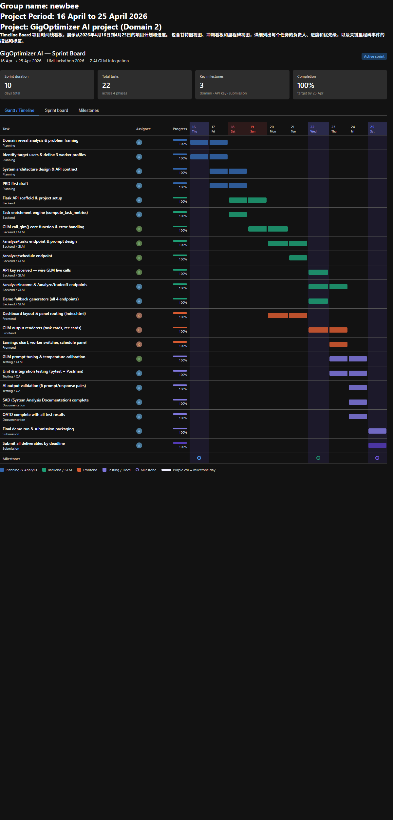
Figure 2 Project Timeline Board
  - Role of Team Members:
Member | Role
Member A (Name: Tan Cai Juan) | Backend Lead
Member B (Name: Wong Jia Hui) | AI/Prompt Engineer
Member C (Name: Lee Jun Rui) | Frontend Developer

  - Recommendations:
- Redis Cache: Cache worker profile blocks and the top-5 task subset server-side for 60 seconds to reduce GLM token usage on repeated calls from the same worker.
- Streaming Response: Implement GLM streaming (SSE) for the income analysis endpoint to improve perceived latency — workers see the strategy text appear progressively rather than waiting for the full JSON.
- PostgreSQL Integration: Replace in-memory WORKER_PROFILES with a database-backed model to persist earned task history across sessions, enriching future GLM context blocks.
- Bahasa Malaysia Prompt Variant: Add a language parameter to the system prompt to generate explanations in Bahasa Malaysia for broader worker accessibility.

